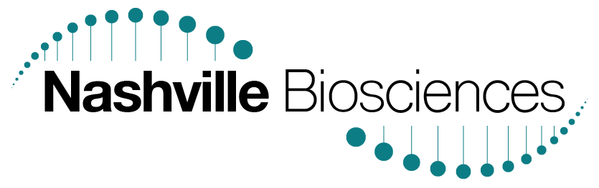

Seeking Head of Business Development for disruptive Nashville biotech startup

This is a full-time/exempt term position lasting six months to one year.

Job Title: Head of Business Development

About Nashville Biosciences (NashBio):
NashBio’s business harnesses a unique genetic database linked to electronic medical records (EMRs) with years of longitudinal clinical data. The dataset is the largest and highest quality of its kind, providing an unprecedented opportunity to glean valuable information from gene-disease associations. The business delivers research insights for pharma and biotech companies resulting in accelerated R&D and efficient clinical trial design. Additionally, biotech spinout companies will be formed from the novel insights derived from the dataset.

Position:
NashBio is currently seeking a Head of Business Development. The position is more expansive than a traditional business development role as it also entails many business building activities and management of the biotech spinout process. The ideal candidate will have a deep understanding of genetics and statistics, have significant experience in the pharmaceutical space, and have a strong entrepreneurial spirit. Responsibilities will primarily focus in two areas:
1. Engaging new and existing biotech and pharma customers on our consulting offerings
2. Engaging investors and stakeholders to expand partnership opportunities and drug development spinouts based on NashBio’s pheWAS technology

The offeree will report directly to the Chief Business Officer.

Additional responsibilities:
  - Work with management to define revenue goals, increase customer base, add to existing customer profitability and expand existing channels
  - Identify new partnership and investment opportunities in close collaboration with CSO and management
  - Manage communication streams and presentations for clients and investors
  - Support creation of proposal materials for proactive business development outreach
  - Help in the creation of new business strategy and work closely with clients and partners to develop customized solutions

Qualifications:
  - Life Sciences Master’s or PhD, with 2 years of relevant work experience
  - Strong understanding of biology and genetics especially as they relate to human disease processes, pharmacology, drug-protein interactions, signaling pathways, etc.
  - Strong analytical capabilities: highly proficient in Excel and financial modeling
  - Strong communication skills: able to create high quality PowerPoint presentations for clients and present pitches in front of senior clients (e.g., heads of R&D, CEOs of biotechs)
  - Previous business experience in pharma or biotech
  - Strong grasp of the current pharma and biotech sector and familiarity with industry players
  - Project management and organizational skills
  - Authorized to work in the US
  - Able to travel within the US and internationally to attend conferences and meet with potential clients (expected travel 25%)

Characteristics:
  - Startup mindset: willingness to grow and adapt quickly as the company changes
  - Collaborator: very comfortable working within multi-disciplinary teams, using a fast-moving iterative approach
  - Creativity: comfortable developing new business strategies and adapting to the needs of the clients

Location:
The offeree may be based in Nashville; otherwise the offeree may be based in the Boston area, New York City or New Jersey, if willing to travel to Nashville for training and regular in-person meetings.

Compensation:
Competitive with other positions in the field.
Interested applicants should email resumes to careers@nashvillebiosciences.com

About us:
We are an exciting biotech startup that is fundamentally changing drug discovery & development processes in biopharma. Soon to be spun out of Vanderbilt University Medical Center, we are the only company of its kind that leverages years of rich longitudinal clinical data and genomic information of hundreds of thousands of individuals to address pressing R&D questions for our clients in the biopharmaceutical industry. We leverage this massive databank, along with unique computational methods developed at VUMC, to offer a range of precision medicine services to biopharma.

We are an equal opportunity employer and prohibit unlawful discrimination based on race, color, religion, gender, sexual orientation, gender identity/expression, national origin/ancestry, age, disability, marital & veteran status.

NOTE:
A Term position is a staff position that exists for a period longer than six months but is not expected to last beyond one year. Although a position may exist for a specified or indefinite period, staff who accept term positions are not guaranteed employment for the entire period; they are employed for indefinite periods within the limit of the appointment. There are no guarantees of continued employment, either within the term or when the term ends.

