SYPRO Ruby fluorescent staining for protein gels
Diego Torres 2/22/24

Goal: The goal of this protocol is to provide an alternate quantitation of protein in EVs from standard assays (BCA, microBCA, etc.), which can overestimate EV protein and/or be thrown off by lipids. This method quantitates protein from the entire lane of a gel, based on comparison to the BenchMark protein ladder. We have found this to frequently be a better estimate of EV protein and very useful for subsequent loading of Western blots and other applications like proteomics.

Materials:
- BenchMark Protein Ladder (#10747-012, Life Technologies)
- SYPRO Ruby fluorescent stain (#S-21900, Life Technologies)
- SYPRO Ruby fix solution (in H₂O)
  - 40% Methanol
  - 10% Acetic Acid
- SYPRO Ruby destaining solution (in H₂O)
  - 10% Methanol
  - 6% Acetic Acid
- 4X SDS sample buffer
- 8% Acrylamide Gel (PAGE)

Procedure
- Prepare samples in 4X SDS sample buffer
  - Mix 5ul of sample + 5ul of 4X SDS sample buffer
  - Heat at 95 C for 5 min
- Load 5 ul of BenchMark Protein Ladder standard of known protein concentration into the gel (1.7 μg/μl – 8.5ul total)
- Load samples into the gel
- Run gel for 30min at 100V, then change to 120V for ________ (variable)

*All incubations should be done in the dark or a dark box
- Fix the gel with SYPRO Ruby fix solution for 45-1h at RT on a shaker
- Stain the gels with SYPRO Ruby fluorescent stain with 5-10 mL of SYPRO Ruby.
  - Incubate for 2 h or overnight (prefer) on shaker at RT
  - After incubation pour SYPRO Ruby solution into a container (SYPRO Ruby dye can be re-used several times)
- Wash gel with SYPRO Ruby destaining solution for 30-45 mins twice
- Image the protein gel using iBright
  - Protein Gel > Protein Fluorescence > Smart Exposure > Capture
  - A second image can be taken with a higher exposure time if needed
*Colors can be inverted, and contrast can be changed
  - Safe a G2i file for analysis
- ImageQuant software (Molecular Dynamics) or suitable densitometry-based analysis software, iBright analysis software has several options to quantify the image.

iBright Analysis
- Load G2i image into iBright analysis software > Select file > click Next
- Adjust Image
  - Invert colors
  - Edit image display enhancement to visualize bands clearly if necessary
  - Straighten the image if necessary
- Analyzed Image tab
  - Change Automatic to Manual
  - Adjust image display to visualize the bands on gel if necessary
  - Don’t show saturation
- Regions Tab
  - Add regions
  - Select rectangle > on the image make a rectangle over the latter/benchmark, make sure it covers everything
  - Copy the rectangle and paste it over each of the sample lanes
*The rectangle should not change sizes from lane to lane
  - Click Apply
- Export > Analysis Report > Preview
  - PDF file > Save

Protein quantification
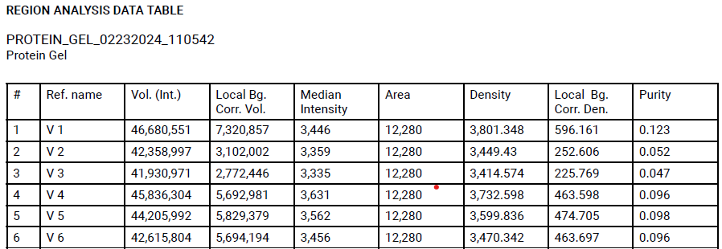
- From the last table of the PDF file copy and paste values from Vol. (Int.) and Local Bg. Corr. Vol. columns into Excel
*Local Bg. Corr. Vol. shows the intensity of bands/columns with the background removed from Vol. (Int.)
- Label each of the samples properly
  - BenchMark Protein Ladder standard will be used to calculate sample concentration
- Multiply values from Local Bg. Corr. Vol. by 8.5 (total concentration loaded in 5ul of the ladder) to calculate intensity per concentration (AU/ug)
- Divide Local Bg. Corr. Vol. by AU/ug to calculate the total amount of protein loaded (ug/column)
  - Each sample should be divided by the number obtained from the BenchMark Protein Ladder standard
- Divide ug/column by 5 (ul loaded from each sample) to calculate concentration per ul (ug/ul)
*Volume loaded from sample can changed adjust the last calculations

