NIH Grant Application Font Issues for conversions to .pdf

**Issue:**

MAC computers (and some PC’s) do not retain font sizes correctly when converting from “Word” to “.pdf” and can cause some applications to be administratively rejected for proposals submitted after 05/25/2016, and recently updated and emphasized for applications submitted after 01/25/2017.

NIH issued an announcement allowing additional font styles as acceptable (we typically have used 11point-Arial), however hidden within both announcements is a MAJOR change to NIH’s acceptance of application narratives within the application.

Here specifically is the most recent announcement: NIH ANNOUNCEMENT: <https://grants.nih.gov/grants/guide/notice-files/NOT-OD-17-030.html>

|  |
| --- |
| For applications submitted for due dates on or after January 25, 2017, text in PDF attachments must follow these minimum requirements:   * **Text Color**: No restriction. Though not required, black or other high-contrast text colors are recommended since they print well and are legible to the largest audience. * **Font size**:  Must be 11 points or larger. Smaller text in figures, graphs, diagrams and charts is acceptable, as long as it is legible when the page is viewed at 100%. * **Type density**:  Must be no more than 15 characters per linear inch (including characters and spaces). * **Line spacing**: Must be no more than six lines per vertical inch.   Since some PDF converters may reduce font size, it is important to confirm that the final PDF document complies with the font requirements.  The following fonts are recommended, although other fonts (both serif and non-serif) are acceptable if they meet the above requirements.   * Arial * Georgia * Helvetica * Palatino Linotype   Legibility is of paramount importance. Applications that include PDF attachments that do not conform to the minimum requirements listed above may be withdrawn from consideration. |

**Issue/Instructions:**

VERY SPECIFICALLY one method to create a .pdf files is to “print to .pdf”. However, this results in reducing 11 Arial font in an original Word document to only 10.80/10.98 Arial font in the resulting .pdf file, which is too small to meet the NIH requirements, on both MAC and PC. They cannot be below 11-pt font (bigger is fine, not smaller).

This has been a known issue for years with the adobe convertor, but until the P.A. effective for 05/25/2016, NIH had ignored or allowed these 10.80/10.98 Arial document due to the software issue. However, they are no longer allowing for this exception and are blatantly clarifying that the final versions must be at least 11-pt font.

**Possible Solutions:**

Our IT expert in POD2 has an open work order with Adobe about this issue because it spans all known versions of MACs and Adobe and/or Office. To date, Adobe has been unable to offer a solution and unwilling to address correcting the issue.

* ONE Solution is instead of printing to .pdf, use “Save As”, then chose “File Format” of “PDF” and make sure the radial button is clicked for “Best for electronic distribution and accessibility” (do NOT use “Best for Printing”) and “Export” to create the .pdf– see screen shot below for sample:

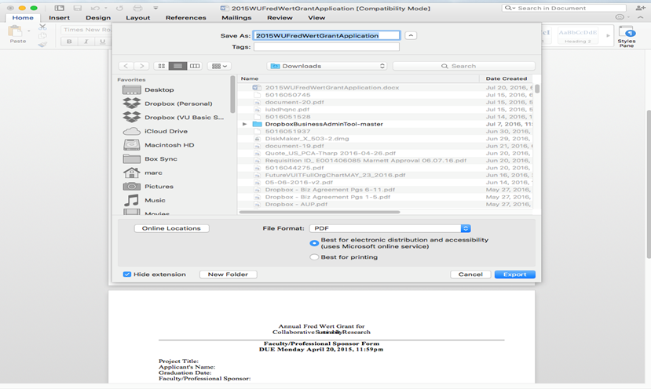

However, even with this solution there are things to monitor:

* + Some older MACs this option may not exist.
* Another solution is to convert the files on a PC using “Save As”, then chose “File Format” of “PDF”, instead of converting on a MAC. This issue of reduced text size after converting a file to .pdf rarely occurs when using a PC and “Save As” instead of “Print” to .pdf, so if the above solution is not successful, finding a PC to create these conversions should work.  It is important to still check the resulting .pdf file
  + Known issue: when opening a Word document originally created on a MAC, you may find that it’s misinterpreted symbols in the text or in figures/tables, changing them to rectangles or question marks.
* Another solution would be just to start with either 11.50 or 12 font. The disadvantage would be that for documents that have page limits or specific line limits, the PI would lose some text by using a larger font, so going through the above steps is suggested to allow PI’s to start with 11-pt font and include as much text as possible to describe their research. Typically, the only documents with page or line limits are: Project Summary (30 lines), Biosketches, Specific Aims, Research Strategy, Introduction (for resubmissions).

**General Comment on documents with no page or line limitations:**

However, there are only a few documents that have page or number-of-line limits. For those documents with no page or line limits to avoid this issue, I would suggest just using 12 Arial font as a starting point. Examples of these documents include: Narrative, Facilities, Equipment, Budget Justification, Bibliography, Resource Sharing Plan, Authentication of BioChem Resources, Cover Letter, Select Agent Research, Progress Report Publication List, Multi-PI Leadership Plan, Vertebrate Animals, and the various Human Subjects narratives. For these, if you use 12-pt font there should be no issue with font sizes decreasing to less-than 11 fonts when converting.

**Checking the font size before submission:**

After converting the file to .pdf, if you then check the font size in the resulting .pdf file. Open the .pdf document right click on text, select “edit text”, a box will appear and show what the font size of the selected text is on the PDF file.

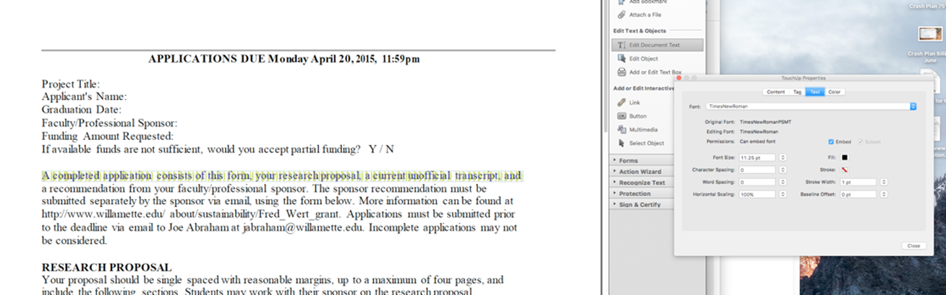

The typical result is an 11.25 or 11.04 font size, this is acceptable because it is okay to be larger than 11-pt font, just not smaller.

As you each experiment with this, if you have other solutions or issues, I’d welcome the feedback. There may be better alternates you can provide to make life easier for us all.

Thanks.